Copyright for test papers and marking guides remains with West Australian Test Papers.
They may only be reproduced within the purchasing school according to the advertised Conditions of Sale.
Test papers should be withdrawn after use and stored securely in the school until Wednesday 1st July 2015



PHYSICS

YEAR 11

Unit 1

2015

Marking Guide

SECTION ONE

Question 1 (4 marks)
- Conduction and convection require matter in order to allow the transfer of heat energy.
- In conduction the particles cause a transfer of vibration by contact with neighbouring particles.
- In convection localised heating in fluids causes expansion which will see a less dense region created. As particles in a fluid can flow the less dense region will rise and cooler more densely packed particles will move into the heating region.
Radiation requires no particles and is simply that region of the EM spectrum that causes molecular motion – namely IR and microwaves. As all EM radiation can travel through vacuum heat energy may be transferred via radiation without particular involvement.
Question 2 (3 marks)
m = 0.01 kg
l_{vap} = 2.25x10⁶ K kg⁻¹
c_{water} = 4180 J kg⁻¹ K⁻¹
ΔT = 100 – 37 = 63 K

Q = m L + m c ΔT
= ( 0.01) x (2250000) + (0.01) x (4180) x (63)
= 25 133.4
= 2.51 x 10⁴ J

Question 3 (4 marks)
(a)
(2 marks)

(b) V = I R
V = 1.5 x 15 = 22.5 V (2 marks)

Question 4 (4 marks)
(a) Sample B. There is the same amount of particles initially, though it has a shorter half life. (2 marks

(b) Sample A. It deposits in greater concentration in bones, and although it has a lower activity a
higher concentration should see a greater effect given that both samples emit beta radiation,
and it is also of higher energy. The length of time spent in the body is indeterminate as a
reason in this question so is not marked as incorrect. (2 marks)

Question 5 (4 marks)
A = 8 Bq A₀ = 242 Bq t_{½} = 5  10⁴ years
$A=A_{o}(\frac{1}{2})^{n}$ $\text{log}(0\text{.}\text{28125})=n\text{log}(\frac{1}{2})$
$8=\text{242}(\frac{1}{2})^{n}$ $\frac{\text{log}(8/{\text{242}})}{\text{log}(\frac{1}{2})}=n$
$\frac{8}{\text{242}}=(\frac{1}{2})^{n}$ n = 4.92
t = n × t_{½}
$\text{log}(\frac{8}{\text{242}})=\text{log}(\frac{1}{2})^{n}$ t = 4.92 × 5  10⁴ = 2.46  10⁵
time taken = 2.46  10⁵years

OR use the following method:

242 > 121 > 60.5 > 30.25 > 15.125 > 7.5625= 5 half lives,
so a little less than 5 half lives = approx 5  5  10⁴ yrs
= approx. 2.50  10⁵ yrs

Question 6 (4 marks)
(a) Either - average KE of water reduced is by high energy particles escaping from the towel in thermal contact with air and leads to heat transfer .
Or
Energy for latent heat of vaporisation is transferred from the head to the towel to evaporating
water. (2 marks)

(b) In high humidity the spaces in atmospheric air have been filled by water vapour molecules, which reduce opportunity for other water molecules to fill this space by evaporation
(1 mark)

(c) Increase air flow, increase surface area. (only one required) (1 mark)

Question 7 (4 marks)
Current is a measure of the flow (drift) of charge per second past a point.
A potential difference is established between two locations and an electric field is formed.
Charge that is free to move is induced to flow through the electric field. (across the potential difference).
Diagram – 1 mark

Question 8 (3 marks)
(a) When current flowing through a non-ohmic resistor is measured against changing potential
difference, the relationship is not linear. (which is the case with an ohmic resistor.)
(2 marks)

(b) 1.3 A (1 mark)
Question 9 (3 marks)
The student did not take into account the following:
The molten rock would undergo a change of phase as it solidified.
The bucket would have a different specific heat to water.
There would be a loss of water from the bucket due to vaporisation as the rock cooled and the water boiled.

Question 10 (2 marks)
absorbed dose = energy / mass
energy = absorbed dose x mass
energy = 2500 x 2 = 5000 J
Question 11 (3 marks)
Circuit 1: Series circuit (1 mark) | Circuit 2: Parallel circuit (1 mark)

(b) Circuit 2 (parallel) (1 mark)

(c) Power dissipated in the globes determine how bright they will be. Power depends upon
resistance. P = V²/R . Resistance in the parallel circuit is half that of the series circuit so in the
formula P = V²/R, the power will be greater in the parallel circuit. (2 marks)
Question 12 (3 marks)
(a) ₅₃I¹³¹ → ₅₄Xe¹³¹ + ₋₁e⁰ (2 marks)

(b) Because of the isotope’s short half life the radiation will not be residual in the body for a long period of time so it is safe to use in this application. (1 mark)

SECTION TWO
Question 16 (14 marks)
(a)
V = I R so I = V/R = 240 /300 = 0.80 A (2 marks)
V = I R so I = V/R = 240 /800 = 0.30 A (2 marks)
(b) Total current = 0.80 + 0.3 = 1.10 A A (2 marks)
or if students need to calculate it:
Total resistance in the circuit
1/R_{total} + 1/R_{X} + 1/R_{Y} = 1/R_{total} = I/300 + 1/800
R_{total} = 218.18 W
V = I R
I = V/R = 240 /218.18 = 1.10 A

(c) No. It is unlikely there would be a problem. Household lighting circuits are typically able to
carry currents of 8 to 10 A before they become overloaded. (2 marks)

(d) Total resistance in the circuit
1/R_{total} + 1/R_{X} + 1/R_{Y} = 1/R_{total} = I/300 + 1/800
R_{total} = 218.18 W (2 marks)

(e) P = V I = 240 x 1.1 = 264 W
= 0.264 kW

The number of hours = 2.0 hours
The number of kWh = 2.0 x 0.264 = 0.528 kWh
Cost = 0.528 x 22.36 = $11.81 cents (4 marks)

Question 17 (10 marks)
(a) Energy released in 1 second = 10 x 10³ x 1.55 x 10⁻¹³ = 1.55 x 10⁻⁹
Energy released in 1 year = = 1.55 x 10⁻⁹ x 365 x 24 x 60 x 60 = 0.04888 J (2 marks)

(b) Energy absorbed per kg = 0.048888/55 = 8.89 x 10⁻⁴ J/kg (2 marks)

(c) A gray is measured in J/kg therefore the radiation dose in grays is 8.89 x 10⁻⁴ Gy
(2 marks)

(d) (i) The quality factor for alpha radiation is 20
dose equivalent = absorbed dose x quality factor = 8.89 10⁻⁴ x 20 = 0.01778 Sv
= 17.78 mSv (2 marks)

(ii) No. The research student is lucky. Absorbing a radiation dose of 17.78 mSv is within
the recommended safe range for workers in the radiation industry, (50 mSv), so there
would be no major concerns about his health. (2 marks)

Question 18 (7 marks)

(a) (i) A-B (1 mark)
(ii) E-F (1 mark)

(b) (i) A-B, C-D and E-F (1 mark)

(ii) B-C and D-E (1 mark)

(c) Time = 1.1 min = 66 s
mass = 1.0 kg
Rate of heating = 20 J/s
Quantity of heat to convert 0.75 kg of solid to liquid = 20 x 66 = 1320 J
Quantity of heat to convert 1.0 kg of solid to liquid = 1.0/075 x 1320 = 1.76 x 10³ J
(3 marks)

Question 19 (13 marks)

- stirring, choosing suitable mass of liquid,
temperature rise and appropriate time for heating. (2 marks)

(b) Q = 0.50 x 4180 x (57 – 23) = 71 060 J (1 mark)

(c) Heat produced per second = 71 060 / 260 = 273.21 watts (3 marks)

(d) Any two
- Some heat goes into heating the glass beaker and the gauze.
- Not all heat from Bunsen heats the beaker, some heat escapes sideways.
- Thermometer accurate to only 1 degree in 34 => 3 % error. (2 marks)

(e) two conditions,
- Bunsen in same position relative to the beaker.
- Bunsen flame same colour
- Gas supply the same (2 marks)

(f) Q = m c ∆T
273.31 x 120 = 0.41 x c x (66 – 23)
32 797.2 = 17.63 x c
c = 1.860 x 10 ³ J kg^{.-1}K⁻¹ (4 marks)

Question 20 (10 marks)
(a) Control rods are used to absorb neutrons to control the nuclear chain reaction that occurs with
the fissile fuel.
In order to do this they are raised and lowered between the fuel “bundles” and by doing so
absorb more or less neutrons allowing a degree of control over how much of the fuel
undergoes decay and releases energy by controlling how many of the neutrons in a decay
event go on to initiate another decay event. (2 marks)

(b)
${}_{\text{55}}^{\text{137}}{}\text{Cs}→{}_{\text{56}}^{\text{137}}{}\text{Ba}+{}_{−1}^{0}{}e$ (1 mark)

${}_{\text{56}}^{\text{137}}{}{\text{Ba}}^{}→{}_{\text{56}}^{\text{137}}{}\text{Ba}+{}_{0}^{0}{}γ$ (1 mark)

(c) If the process is 40% efficient and the eventual output is 950 MW,
then 950 / 0.40 = 2375 MW is required to be produced from the U-235.
1 decay releases 200 MeV = 200 x 1.6x10⁻¹³ J = 3.2 x 10⁻¹¹ J per decay.
If 2375 x 10⁶ J are required every second the amount of decays per second required is:
2375 x 10⁶ ÷ 3.2 x 10⁻¹¹ = 7.422 x 10¹⁹ decays per second.
In one day there are 60 x 60 x 24 = 86 400 seconds, therefore the number of atoms
undergoing decay in one day: 7.422 x 10¹⁹ x 86 400 = 6.413 x 10²⁴ decays
If the mass of one U-235 nucleus is 3.90625x10⁻²³ kg, then the total mass of U-235 consumed
in one day = 3.90625x10⁻²³ x 6.413 x 10²⁴ = 250.5 kg. (6 marks)

Question 21 (8 marks)

(a) V = 1.00 x 10⁹ V
q = 40.0 C
E = qV
= 40 x 1.00 x 10⁹
= 4.0 x 10¹⁰ J (3 marks)
(b) q = 40.0 C
t = 1.11 x 10⁻² seconds
I = q ÷ t
= 40 ÷ 1.11 x 10⁻²
= 3.60 x 10³ A (3 marks)
(c) Any action that would mean you are not the highest point in an otherwise exposed area.
For example: not in the sea, not holding aloft an umbrella or metal object such as a golf club,
not standing under a tree. (2 marks)

Question 22 (11 marks)
(a) Mass of reactants = 13.999234 + 1.00728 = 15.006514
Mass of daughter products = 14.998677

Δm = 15.006514 - 14.998677 = 0.007837 u
E (MeV) = Δm (u) × 931
E = 0.007837 × 931 = 7.30
E = 7.30 MeV (2 marks)

(b) Kinetic energy of the daughter products
Energy associated with the gamma radiation
Increased particle vibration of the daughter products (heat energy) (2 marks)
Any 2 acceptable examples

(c) Binding energy is the (mechanical) energy required to disassemble a whole into separate
parts. In this case the energy required to separate a nucleus into the individual nucleons that it
comprises. (2 marks)
Or
The energy released to the surroundings when a nucleus is formed from individual nucleons.

(d) Mass of individual nucleons = (8  1.00728) + (8  1.00867) = 16.12760

Δm = 16.12760 - 15.990526 = 0.137074 u

E (MeV) = Δm (u) × 931
E = 0.137074 × 931 = 127.615894 MeV
BE per nucleon = 127.615894 / 16 E = 7.98 MeV per nucleon (3 marks)

(e) If the student calculated the BE correctly then their answer would be something like:
“Yes the value of about 8 MeV per nucleon agrees with the graph because a mass number of
16 (oxygen ) shows a value of about 8 MeV on the graph”.
If the student calculated a value different to 7.98 MeV then their answer would be something
like; “ No. The values do not agree. The correct value is about 8 MeV because oxygen has an
atomic number of 16, which shows a BE per nucleon of about 8 MeV. My value is different to
that!
Both answers should be marked correct because they demonstrate an understanding of the concept. (2 marks)

Question 23 (11 marks)
(a) The compressor subjects the gas to a rapid increase in pressure. As a result the gas begins to condense, transferring its latent heat to the warm outside air. (2 marks)

(b) Outside the house. (1 mark)

(c) Air is fed through the condenser to extract heat energy. (2 marks)

(d) It is placed just before the evaporator. It feeds the refrigerant into a low pressure region. (2 marks)

(e) The low pressure region induces a phase change from liquid to gas. This requires energy, the
latent of vaporisation, which is taken from air inside the house by passing it through the
evaporator. This reduces the air temperature. (2 marks)

(f) Volatility- its ability to easily change phase with pressure variation.
Boiling point at around room temperature.
Whether it is a chemical hazard.
Environmental impacts if released. (2 marks)

Any 2 reasonable points

Question 24 (6 marks)
(a) For the 60 Ω lamp
P = V² / R = 240² / R
R = 240² / 60
R = 960 Ω (2 marks)

For the 75 Ω lamp
P = V² / R = 240² / R
R = 240² / 75
R = 768 Ω (2 marks)

(b) The ‘smart” lamps are operating with much less power cf 18 W versus 75 W and so are
consuming less electricity, so cost less to run.
They have a longer life because they are operating with a different technology which does not
rely upon fragile filaments with high resistances. (2 marks)

SECTION THREE

Question 25 (18 marks)

(a) (2 marks)

Heat in (Q)  (J x 10 ⁵) | Temperature  Τ₂ (ºC) | Temperature  Τ₁ (ºC) | Τ₂ − Τ₁
7.6 | 80 | 55 | 25
3.8 | 70 | 57 | 13
2.2 | 55 | 49 | 6
2.9 | 40 | 31 | 9
4.5 | 35 | 20 | 15

(b) (4 marks)
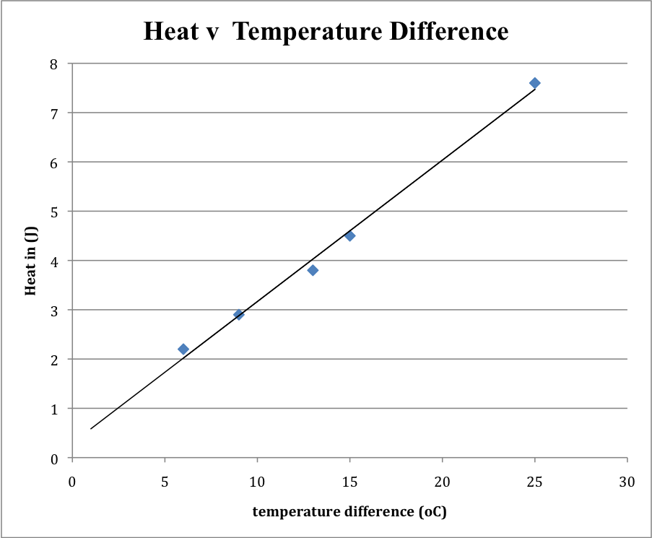

gradient of graph is 0.2706

(c)
$Q = \text{}\frac{k A \left(T_{2}\text{}−\text{}T_{1}\right) × \text{}t}{L}$

k = L x [Q / (T₁-T₂)] / [A x t]
k = 0.75 x 0.2706 /(0.035 x 120)
k = 4.83 x 10⁻² W m⁻¹ ºC⁻¹

The coefficient of thermal conductivity (k) = 4.83 x 10⁻² W m⁻¹ ºC⁻¹ (7 marks)

(d) The major consideration is to insulate the rod so all the heat produced is transferred in the metal
and does not escape to the surroundings.
Keeping the conditions identical between each trial. (2 marks)

(e) By repeating multiple trials any errors in measurements are reduced due to an averaging process. (2 marks)

(f) Polymers usually have lower melting temperatures so would melt during high temperature
experiments. (1 mark)

FUTURE ENERGY
Article adapted from “Future Energy”, by David Shiga, New Scientist; 3/26/2011, Vol. 209 Issue 2805, p8-10, 3p

Sorenson and others propose building reactors that use a naturally occurring element called thorium as the main starting material, instead of uranium or plutonium. Though the technology is far from fully developed and very different to conventional plants based on solid uranium and plutonium fuel, advocates say it would be immune to the problems that have plagued the Fukushima reactors and should produce less radioactive waste than conventional reactors.

At the heart of a liquid fluoride thorium reactor (LFTR) is a chamber filled with thorium-232 dissolved in a molten salt such as lithium fluoride at several hundred degrees Celsius. Thorium-232 itself is barely radioactive, so a small amount of uranium-233 is added to kick-start nuclear reactions. Like U-235, it is radioactive and so fissions, releasing heat as well as neutrons. These hit thorium atoms, transforming them into more U-233 and producing heat in the process. The U-233 in turn fissions to produce more neutrons. "It is a continual process of turning thorium into U-233, burning it up and generating new U-233," says Sorensen.

The fuel cools as it passes through a heat exchanger containing more molten salt, and this heated salt can then be used to drive turbines and generate electricity. Without water as a coolant, there is a much lower risk of explosions. At Fukushima, these were caused by the build-up of steam and the generation of hydrogen by the breakdown of water.

A liquid fuel also reduces the volume of radioactive waste. In conventional uranium reactors, the solid fuel rods have to be removed from the core long before their radioactive waste products have decayed and the uranium fuel has been used up. That's because too much radiation makes the fuel rods swell and crack, allowing radiation to leak out.

By contrast, the fuel in a liquid reactor is unaffected by radiation and so can continue to be used until virtually all its radioactive components have undergone further reactions, or decayed into non-radioactive waste products.

Another advantage is that, unlike conventional solid fuel rods, fluoride salts are not flammable. If solid rods catch fire they release plumes of radioactive smoke.
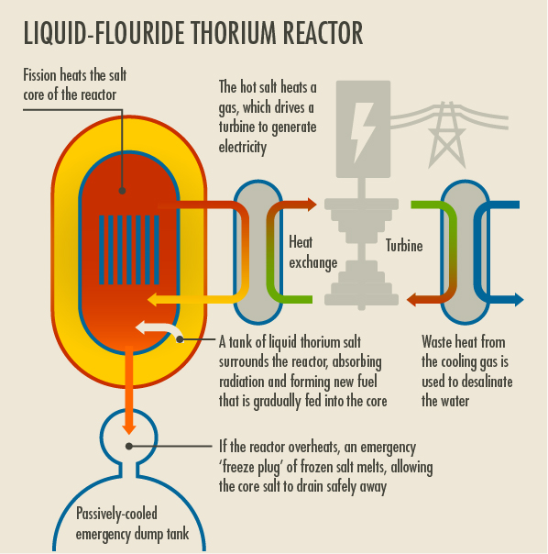

- Thorium-232 is “barely radioactive”. How can it be used as a nuclear fuel? (2 marks)
U-233 is added. This undergoes fission, producing neutrons that are absorbed by the Th-232, turning it into more radioactive U-233 and heat, which undergoes fission producing more neutrons to be absorbed by Th-232 and heat. 

- Uranium-233 is produced in a thorium reactor from Thorium-232, via Thorium-233 and Pa-233. Write the three (3) nuclear reactions responsible for the production of
U-233 in the reactor. (6 marks)





- Water is not used as a coolant in a thorium reactor. Explain why water is not needed and why it is a major advantage to not have water present in the reactor. (2 marks)
A molten salt such as lithium fluoride is used as the coolant. 
There is a much lower risk of explosions caused by high temperature and pressure steam 
- Thorium reactors “produce less radioactive waste”. Explain why. (3 marks)
In traditional reactors, radiation damages the fuel rods causing them to swell and crack. So the fuel rods have to be removed before they are fully spent and the radioactive waste material has decayed.  In a thorium reactor, the fuel is embedded in the coolant and is unaffected by radiation  so the fuel and wastes can decay into non-radioactive material, while constantly producing more heat, 
- Pa-233 is produced as an intermediate (part (b) above). Pa-233 has a half life of about 27 days, meaning that substantial amounts of Pa-233 are present in a thorium rector. Why could this be a disadvantage? (2 marks)
The Pa-233 could absorb neutrons and therefore hinder the absorption of neutrons by the Thorium. 

- Briefly describe an environmental advantage that all nuclear reactors have over traditional fossil fuel power plants. (2 marks)
Eg: Nuclear reactors do not produce carbon dioxide, which has been shown to be a major contributor to climate change. 

